**Deep Learning Model for Alphabet Soup**

**Overview:**

The purpose of this analysis develop a tool for a non profit foundation, Alphabet Soup to use to help select applicants for funding with the best chance of success. Alphabet Soup provided a CSV with more than 34,000 organizations that received funding from Alphabet Soup. The goal was to provide a model that could predict with a 75% success rate.

The following Data was provided;

EIN/Name, Applications type, Affiliation, Classification, Use Case, Organization, Status, Income Amount, Special Considerations, Ask amount, and Successful

**Results**:

The targets “y” of the model were “Is Successful”

The variables that were features of the model (X) were the following;

Ask Amount, Application type, Income amount, and special considerations

Right off the bat there were two items from the data set that were dropped because they were neither targets, nor features. Those were EIN and Name. They were dropped from the Data set to start.

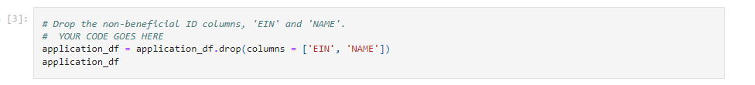

For my first test, I used 2 layers, with activation functions, “relu” ad an output lay with an activation of sigmoid. See Settings below;

This model did not meet the initial target model performance goal of 75%. The test model only achieves 72.6% accuracy.

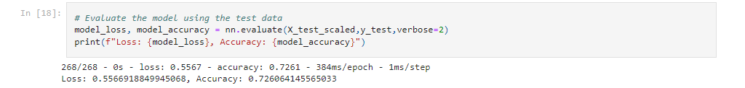

Some ways to increase the model performance would be to increase the number of layers and to change the number of hidden layers. I did this in a couple of other attempts but was till unable to get to the target goal. Below was my best attempt

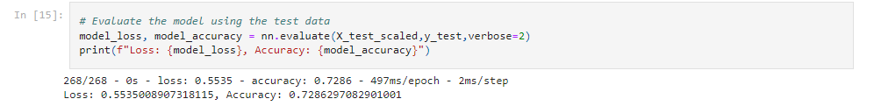

Summary:

In summary, we were unable to achieve the set goal of 75%. I would recommend using a random forrest model. Random forrest is built to help solve classification problems.